16 August 2023

Building & Construction Team
Better Regulation Division | Department of Customer Service

E: bcr@customerservice.nsw.gov.au

Dear Sir/Madam

PRACTICE STANDARD FOR PROFESSIONAL ENGINEERS

Thank you for the opportunity to comment on the draft Practice Standard for Professional Engineers.

The Owners Corporation Network of Australia Limited (OCN) is the peak consumer body representing and advocating the rights and interests of residential strata title, community title, and company title owners and occupiers.

The protection of consumers through the delivery of high quality, sustainable homes and a robust dispute resolution system is of paramount public importance.

In NSW, urban consolidation has been a goal of successive Governments resulting in a rapid expansion of the residential strata sector. The emphasis on increasingly tall and more complex apartment buildings to house a growing population demands that only the most suitably qualified professionals are permitted to undertake this work. However, failures in the regulatory system and in the construction industry have led to systemic defects in high rise apartment buildings.

OCN therefore supports the intent of the documentation, which provides essential guidelines that will raise the standards of engineering practices in this professional community. Further, we would like to see clear guidelines and disciplinary procedures applied to all building consultants, many of whom are builders and are typically members of associations like the Institute of Building Consultants which may have a well-defined code of ethics but lack disciplinary functions.

In talking to various industry and legal experts about this proposed Practice Standard, questions were raised about its need given the Court and NCAT each have longstanding, almost identical codes of conduct. The problem appears to be non-compliance with those Codes of Ethics and reluctance of the Court and NCAT to call out the “guns for hire” for their behaviour. Perhaps effort could be better channelled into enforcement of existing Codes?

Yours sincerely

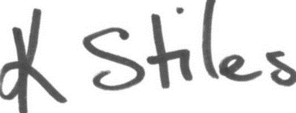
Karen Stiles
Executive Director

