Use your elbow to  
touch lift buttons

用肘部触摸电梯按钮

Use your elbow to  
touch lift buttons

用肘部触摸电梯按钮

Use your elbow to  
touch lift buttons

用肘部触摸电梯按钮

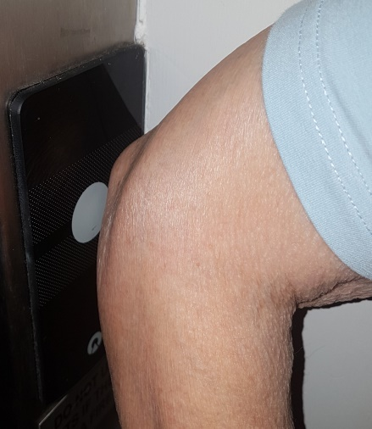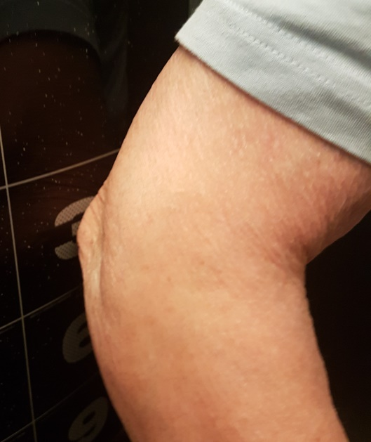

Use your elbow to  
touch lift buttons

用肘部触摸电梯按钮

Use your elbow to  
touch lift buttons

用肘部触摸电梯按钮

Use your elbow to  
touch lift buttons

用肘部触摸电梯按钮

Use your elbow to  
touch lift buttons

用肘部触摸电梯按钮

Use your elbow to  
touch lift buttons

用肘部触摸电梯按钮

Use your elbow to  
touch lift buttons

用肘部触摸电梯按钮